Lab Report : Comparison of Battery Performance by Brand

Aug 31st, 2011

Felicity Longbottom

Lab Partners: Cuthbert Potter, Eileen Dover

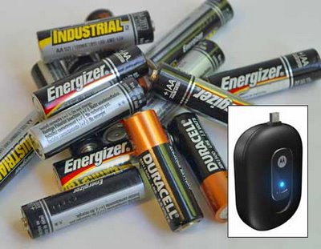

Introduction

Batteries operate numerous items that are used daily. They provide power to objects including flashlights through chemical reactions, which cause an electrical difference to occur between the anode and cathode inside the battery. Electrons flow from the anode to the cathode through a closed circuit, generating power. As these electrical processes occur, chemical changes take place at the anode and cathode, and they no longer possess the ability to supply electrons. Therefore, batteries will only provide power for a specific amount of time before expiring.

This experiment tests which of three battery brands lasts the longest in a standard flashlight. The three brands include Energizer, Duracell, and the Walgreen’s generic brand. It is hypothesized that the Energizer battery will outlast the other two brands. If the Energizer battery lasts longer, then the flashlight containing the Energizer battery will remain on after the other two flashlights lose power.

Materials

- 3 “Great Neck 2 Pc. 9 LED” Flashlights
- 9 AAA Duracell Batteries (New)
- 9 AAA Energizer Batteries (New)
- 9 AAA Walgreen’s Generic Batteries (New)
- 3 Stop Watches (with seconds timer)
- 1 Watch
- 1 Clipboard with timeline chart

Procedure

- Gather all materials and find a test location that provides an equal temperature and environment.
- Insert 3 AAA Duracell Batteries into one “Great Neck” Flashlight.
- Insert 3 AAA Energizer Batteries into one “Great Neck” Flashlight.
- Insert 3 AAA Walgreen’s Generic Batteries into one “Great Neck” Flashlight.
- Turn each flashlight on and start the stopwatch for that corresponding flashlight at the same time.
- Return to the room with the flashlights on the half hour and the hour according to one’s watch and check if the flashlights are still running.
- If the flashlights are still running, place a check mark in the time, noting that the flashlight is still running.
- If one of the lights is no longer on, mark the time in which the light went off to the nearest half or full hour.
- Wait until all three flashlights have stopped working and the times have been recorded.
- Repeat Steps #2-#9 two more times for a total of 3 trials.

Data

Battery | 12:30 | 1:00 | 1:30 | 2:00 | 2:30 | 3:00 | 3:30 | 4:00 | 4:30
Energizer | ✓ | ✓ | ✓ | ✓ | ✓ | ✓ | ✓
Duracell | ✓ | ✓ | ✓ | ✓ | ✓ | ✓
Walgreens | ✓ | ✓ | ✓ | ✓ | ✓ | ✓ | ✓ | ✓

Battery Used | Start Time | End Time | Time Elapsed
Energizer | 12:30 | 3:30 | 180min
Duracell | 12:30 | 3:00 | 150min
Walgreens | 12:30 | 4:00 | 210min

Analysis

Time (min) vs. Battery Brand

Conclusions

The purpose of the experiment was to test which of three battery brands lasts the longest in a standard flashlight. It was hypothesized that Energizer batteries would last longer than the other two brands. At the completion of the experiment, it was found that the hypothesis was unsupported. The Walgreens generic brand surprisingly outlasted the other two name brand batteries by at least 30 minutes.

Though care was taken to place each battery under the exact same conditions for the testing, there are some places where errors could occur. These are highlighted below:
- Though the batteries were all new from the store, there was no indication of how long each brand had been on the shelf. It is very feasible that shelf life would have an impact upon performance.
- There was no guarantee that all the flashlights were identical and it is possible that the current draw on them were different.
- As the flashlights became dimmer, it was hard to determine when the lamp was lit or not.

The experiment revealed that the Walgreens Generic Brand performed better than Energizer and Duracell. To make a conclusive statement it is recommended that further tests would include purchasing batteries from more than one store, and adding current sensors to allow for some quantitative measurements over time.

