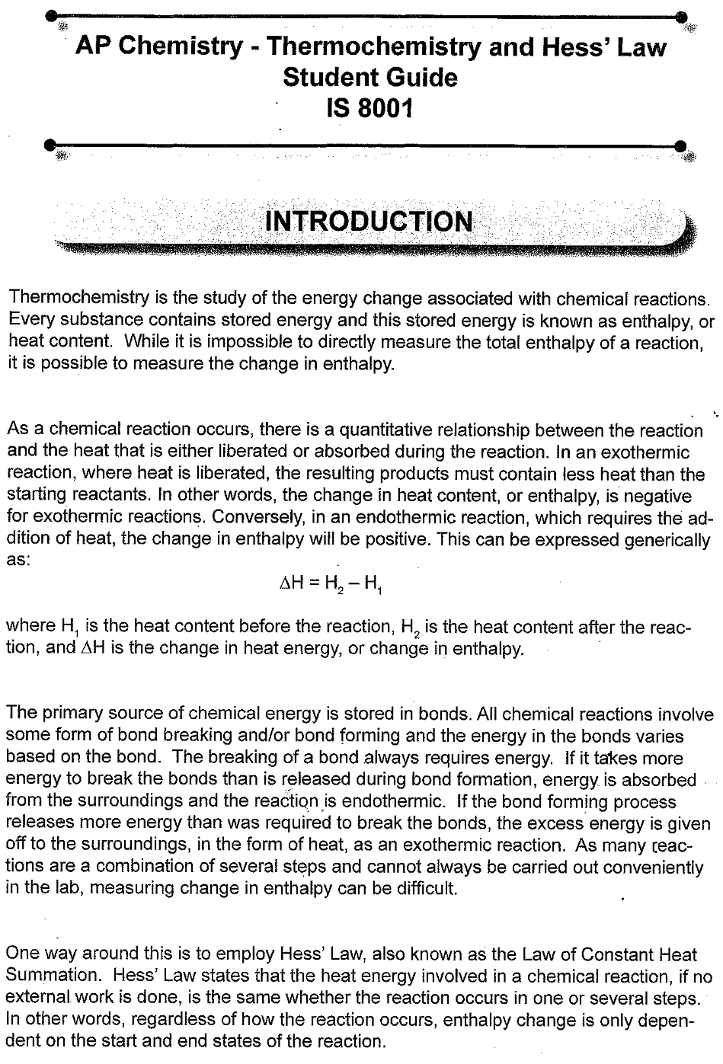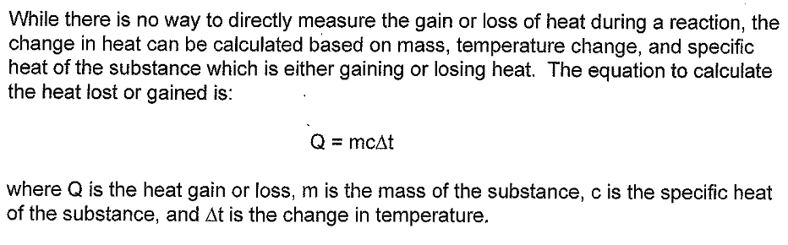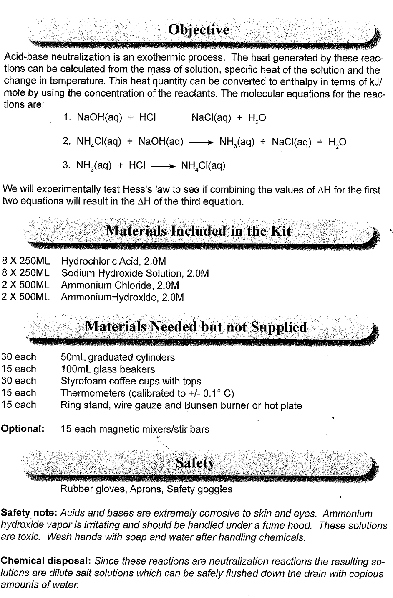



MATERIALS

|  |  |
| --- | --- |
| LabQuest | 2.0 M Hydrochloric acid |
| LabQuest App  Temperature Probe  Ring stand | 2.0 M Sodium hydroxide  2.0 M Ammonium Chloride  2.0 M Ammonium Hydroxide |
| Utility clamp | 100 mL graduated cylinder |
| two 250 mL beakers | glass stirring rod |
| Styrofoam cup |  |
|  |  |

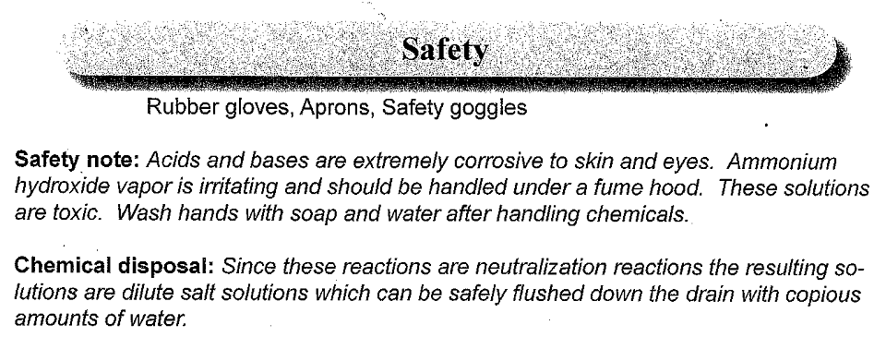

PROCEDURE

1. Obtain and wear goggles. Conduct this experiment in a well-ventilated room.

2. Connect the Temperature Probe to LabQuest and choose New from the File menu. If you have an older sensor that does not auto-ID, manually set up the sensor.

3. Change the data-collection rate to 30 samples/minute and the length to 5 minutes.

4. Nest a Styrofoam cup in a 600. mL beaker as shown in Figure 1. Place a 100. mL beaker in the Styrofoam cup. Measure out 40.0 mL of 2.0 M hydrochloric acid into the 100. mL beaker within the foam cup. **CAUTION:** *Handle the hydrochloric acid with care. It can cause painful burns if it comes in contact with the skin*.

5. Use a utility clamp to suspend the Temperature Probe from a ring stand (see Figure 1). Lower the Temperature Probe into the HCl solution.

6. Measure out 40.0 mL of 2.0 M NaOH solution. **CAUTION:** *Sodium hydroxide solution is caustic. Avoid spilling it on your skin or clothing*.

7. Start data collection and record the initial temperature of the HCl solution. After   
3–4 readings have been plotted, add the 40.0 mL of NaOH solution to the foam cup all at once. Stir the reaction mixture gently.

8. Data collection will stop after 5 minutes.

9. Determine the initial and maximum temperature readings during the reaction.

1. Choose Statistics from the Analyze menu.
2. Record the initial and maximum temperatures in your data table. If the minimum temperature is not a suitable initial temperature, examine the graph and determine the initial temperature.

Store the data from the first run by selecting the File Cabinet icon.

10. Rinse and dry the Temperature Probe, Styrofoam cup, and stirring rod. Dispose of the solution as directed.

11. Repeat Steps 4–10 to conduct the same experiment with ammonium chloride and sodium hydroxide, then ammonium hydroxide and hydrochloric acid. Save a copy of the each graph and email them to yourself.

DATA TABLE

|  |  |  |  |
| --- | --- | --- | --- |
|  | HCl/NaOH | NH4Cl/NaOH | NH3/HCl |
| Maximum temperature (°C) |  |  |  |
| Initial temperature (°C) |  |  |  |
| Temperature change (∆*T*) |  |  |  |

1. Use the equation below to calculate the amount of heat energy, *q*, produced in each reaction. In determining the mass, *m*, of the solution use 1.03 g/mL for the density. Use 4.18 J/(g•°C) as the specific heat, *Cp*, of the solution.

*q* = *Cp* × *m* × ∆*T*

2. Verify Hess’ Law by writing the equations for each reaction and show how you can find the third equation algebraically from the first two equations. Calculate the value of ∆*H* of the third reaction from the values of the first two using Hess’ Law.

3. Find the percent difference between calculated and measured values for reaction #3. Do the measured values support Hess’ Law?