Chapter 12 Problem Set Name _____________________________
Chemical Kinetics

Reaction Rates
1. Consider the reaction: 4 PH_{3 (g)} P_{4 (g)} + 6 H_{2 (g)}
If, in a certain experiment, over a specific time period, 0.0048 mol PH₃ is consumed in a 2.0 L container each second of reaction, what are the rates of production of P₄ and H₂ in the experiment?

2. At 40°C, H₂O_{2 (aq)} will decompose according to the following reaction: 2 H₂O_{2 (aq)} 2 H₂O _{(l)} + O_{2 (g)}
The following data were collected for the concentration of H₂O₂ at various times.

Time (s) | [H₂O₂] (mol/L)
0 | 1.000
2.16 x 10⁴ | 0.500
4.32 x 10⁴ | 0.250

a) Calculate the average rate of decomposition of H₂O₂ between 0 and 2.16 x 10⁴ s. Use this rate to calculate the average rate of production of O_{2 (g)} over the same time period.

b) What are these rates for the time period 2.16 x 10⁴ s to 4.32 x 10⁴ s?

3. The rate law for the reaction Cl_{2 (g)} + CHCl_{3 (g)} HCl _{(g)} + CCl_{4 (g)} is Rate = k [Cl₂]^{1/2} [CHCl₃]
What are the units for k, assuming time in seconds and concentration in mol/L?

Rate Laws from Experimental Data: Initial Rates Method
4. The reaction 2 NO _{(g)} + Cl_{2 (g)} 2 NOCl _{(g)} was studied at -10°C. The following results were obtained experimentally:
[NO]₀ (mol/L) | [Cl₂]₀ (mol/L) | Initial Rate (mol/L · min)
0.10 | 0.10 | 0.18
0.10 | 0.20 | 0.36
0.20 | 0.20 | 1.45

a) What is the rate law?

b) What is the value of the rate constant?

5. The decomposition of nitrosyl chloride was studied: 2 NOCl _{(g)} 2 NO _{(g)} + Cl_{2 (g)}
The following data were obtained experimentally:

[NOCl]₀ (molecules/cm³) | Initial Rate (molecules/cm³·s)
3.0 x 10¹⁶ | 5.98 x 10⁴
2.0 x 10¹⁶ | 2.66 x 10⁴
1.0 x 10¹⁶ | 6.64 x 10³
4.0 x 10¹⁶ | 1.06 x 10⁵

a) What is the rate law?

b) Calculate the rate constant.

c) Calculate the rate constant when concentrations are given in moles per liter.

6. The following data were obtained for the gas-phase decomposition of dinitrogen pentoxide,
2 N₂O_{5 (g)} 4 NO_{2 (g)} + O_{2 (g)}

[N₂O₅]₀ (mol/L) | Initial Rate (mole/L·s)
0.0750 | 8.90 x 10⁻⁴
0.190 | 2.26 x 10⁻³
0.275 | 3.26 x 10⁻³
0.410 | 4.85 x 10⁻³

Write the rate law and calculate the value of the rate constant.

7. The following data were obtained for the reaction,
2 ClO_{2 (aq)} + 2 OH⁻ _{(aq)} ClO₃⁻_{(aq)} + ClO₂⁻ _{(aq)} + H₂O _{(l)}

[ClO₂]₀ (mol/L) | [OH⁻]₀ (mol/L) | Initial Rate (mol/L · min)
0.0500 | 0.100 | 5.75 x 10⁻²
0.100 | 0.100 | 2.30 x 10⁻¹
0.100 | 0.0500 | 1.15 x 10⁻¹

a) Determine the rate law and value of the rate constant.

b) What would be the initial rate for an experiment with [ClO₂]₀ = 0.175 mol/L and [OH⁻]₀ = 0.0844 mol/L?

Integrated Rate Laws

8. A certain reaction has the following general form: aA bB
At a particular temperature and [A]₀ = 2.00 x 10⁻² M, concentration versus time data were collected for this reaction, and a plot of ln [A] versus time resulted in a straight line with a slope value of -2.97 x 10⁻² min⁻¹.

a) Determine the rate law, the integrated rate law, and the value of the rate constant for this reaction.

b) Calculate the half-life for this reaction.

c) How much time is required for the concentration of A to decrease to 2.50 x 10⁻³ M?

9. A certain reaction has the following general form: aA bB
At a particular temperature and [A]₀ = 2.80 x 10⁻³ M, concentration versus time data were collected for this reaction, and a plot of 1/[A] versus time resulted in a straight line with a slope value of +3.60 x 10⁻² L/mol·s.

a) Determine the rate law, the integrated rate law, and the value of the rate constant for this reaction.

b) Calculate the half-life for this reaction.

c) How much time is required for the concentration of A to decrease to 7.00 x 10⁻⁴ M?

10. Experimental data for the reaction A 2 B + C have been plotted in the following three different ways (with concentration units in mol/L):

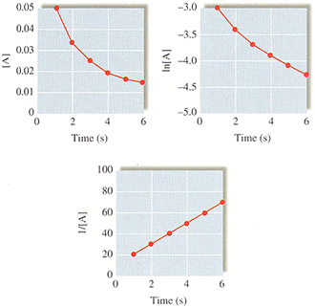

a) What is the order of the reaction with respect to A?

b) What is the initial concentration of A?

c) What is the concentration of A after 9 seconds?

d) What are the first three half-lives for this experiment?

11. The radioactive isotope ³²P decays by first-order kinetics and has a half-life of 14.3 days. How long does it take for 95% of a sample of ³²P to decay?

12. The rate law for the decomposition of phosphine (PH₃) is: Rate = k [PH₃]
It takes 120. s for 1.00 M PH₃ to decrease to 0.250 M. How much time is required for 2.00 M PH₃ to decrease to a concentration of 0.350 M?

13. The rate law for the reaction below is: Rate = k[NOBr]²
2NOBr _{(g)} 2 NO_{(g)} + Br_{2 (g)}

a) If the half-life for this reaction is 2.00 s when [NOBr]₀ = 0.900 M, calculate the value of k for this reaction.

b) How much time is required for the concentration of NOBr to decrease to 0.100 M?

14. For the reaction A products, successive half-lives are observed to be 10.0, 20.0, and 40.0 min for an experiment in which [A]₀ = 0.10 M. Calculate the concentration of A at the following times.

a) 80.0 min

b) 30.0 min

Reaction Mechanisms

15. Write the rate laws for the following elementary reactions.

a) CH₃NC _{(g)} CH₃CN _{(g)}

b) O_{3 (g)} + NO _{(g)} O_{2 (g)} + NO_{2 (g)}

c) O_{3 (g)} O_{2 (g)} + O _{(g)}

d) O_{3 (g)} + O _{(g)} 2 O_{2 (g)}

16. For the reaction 2 H_{2 (g)} + 2 NO _{(g)} N_{2 (g)} + 2 H₂O _{(g)}, the observed rate law is: Rate = k[NO]²[H₂]. The mechanisms shown below have been proposed to explain the kinetics of this reaction. Which of the following are acceptable mechanicsms?

Mechanism I: 2 H_{2 (g)} + 2 NO _{(g)} N_{2 (g)} + 2 H₂O _{(g)}

Mechanism II: H_{2 (g)} + NO _{(g)} H₂O _{(g)} + N _{(g)} Slow
N _{(g)} + NO _{(g)} N_{2 (g)} + O _{(g)} Fast
H_{2 (g)} + O _{(g)} H₂O _{(g)} Fast

Mechanism III: H_{2 (g)} + 2NO _{(g)} N₂O _{(g)} + H₂O _{(g)} Slow
N₂O _{(g)} + H_{2 (g)} N_{2 (g)} + H₂O _{(g)} Fast

17. The mechanism for the reaction of nitrogen dioxide with carbon monoxide to form nitric oxide and carbon dioxide is thought to be:

NO₂ + NO₂ NO₃ + NO Slow
NO₃ + CO NO₂ + CO₂ Fast

a) Write the rate law expected for this mechanism.

b) What is the overall balance equation for the reaction?

Temperature Dependence of Rate Constants and the Collision Model
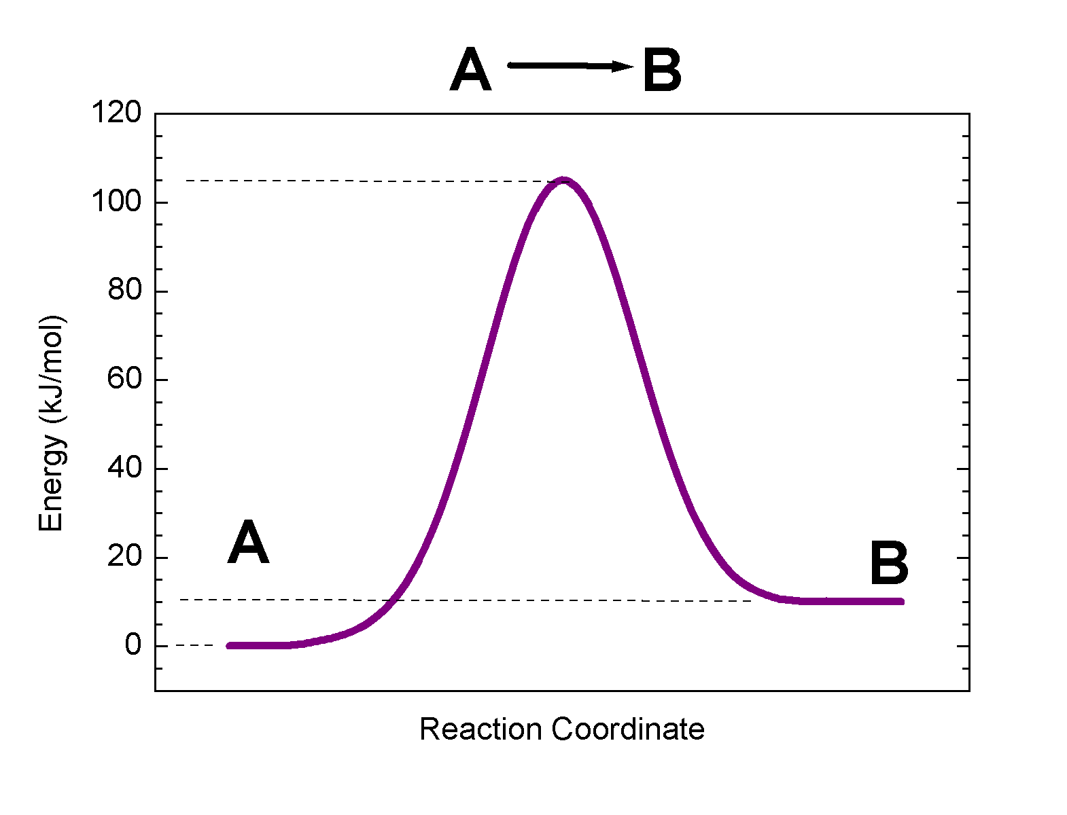
18. For the following reaction profile, label the following:
a) the positions of the reactants and products.
b) the activation energy.
c) ΔE for the reaction.

19. Draw a rough sketch of the energy profile for each of the following reactions:

a) ΔE = +10 kJ/mol, E_{a} = 25 kJ/mol

b) ΔE = -10 kJ/mol, E_{a} = 50 kJ/mol

c) ΔE = -50 kJ/mol, E_{a} = 50 kJ/mol

20. For a certain process, the activation energy is greater for the forward reaction than for the reverse reaction. Does this reaction have a positive or negative value for ΔE?

21. A first-order reaction has rate constants of 4.6 x 10⁻² s⁻¹ and 8.1 x 10⁻² s⁻¹ at 0°C and 20.°C, respectively. What is the value of the activation energy?

22. A certain reaction has an activation energy of 54.0 kJ/mol. As the temperature is increased from 22°C to a higher temperature, the rate constant increases by a factor of 7.00. Calculate the higher temperature.

23. Which of the following reactions would you expect to proceed at a faster rate at room temperature? Why? (Hint: Think about which reaction would have the lower activation energy).
2 Ce⁴⁺ _{(aq)} + Hg₂²⁺ _{(aq)} 2 Ce³⁺ _{(aq)} + 2Hg²⁺ _{(aq)}
H₃O⁺ _{(aq)} + OH⁻ _{(aq)} 2 H₂O _{(l)}

Catalysts
24. One mechanism for the destruction of ozone in the upper atmosphere is
O_{3 (g)} + NO _{(g)} NO_{2 (g)} + O_{2 (g)} Slow
NO_{2 (g)} + O _{(g)} NO _{(g)} + O_{2 (g)} Fast
Overall Reaction: O_{3 (g)} + O _{(g)} 2 O_{2 (g)}

a) Which species is a catalyst?

b) Which species is an intermediate?

c) E_{a} for the uncatalyzed reaction O_{3 (g)} + O _{(g)} 2 O₂ is 14.0 kJ. E_{a} for the same reaction when catalyzed is 11.9 kJ.
What is the ratio of the rate constant for the catalyzed reaction to that for the uncatalyzed reaction at 25°C? Assume that the frequency factor A is the same for each reaction.

25. The activation energy of a certain uncatalyzed biochemical reaction is 50.0 kJ/mol. In the presence of a catalyst at 37°C, the rate constant for the reaction increases by a factor of 2.50 x 10³ as compared with the uncatalyzed reaction. Assuming the frequency factor A is the same for both the catalyzed and uncatalyzed reactions, calculate the activation energy for the catalyzed reaction.

Answers to Selected Problems
1. Rate (P₄) = 0.0006 M/s; Rate (H₂) = 0.0036 M/s
2. a) Ave Rate (H₂O₂) = 2.31 x 10⁻⁵ M/s; Ave Rate (O₂) = 1.16 x 10⁻⁵ M/s
b) Ave Rate (H₂O₂) = 1.16 x 10⁻⁵ M/s; Ave Rate (O₂) = 5.79 x 10⁻⁵ M/s
4. b) k = 180 L²/mol²min
5. b) k = 6.6 x 10⁻²⁹ cm³/molecule s; c) 4.0 x 10⁻⁸ L/mol s
6. k = 0.0119 s⁻¹
7. a) k = 230. L²/mol² min; b) Rate = 0.594 M/min
8. a) k = 2.97 x 10⁻² min⁻¹; b) t_{1/2} = 23.3 min; c) t = 70.0 min
9. a) k = 3.60 x 10⁻² L/mol s; b) t_{1/2} = 9.92 x 10³ s; c) t = 2.98 x 10⁴ s
10. b) [A] = 0.50 M; c) [A] = 9.0x10⁻³ M; d) 1st = 2s, 2nd = 4s, 3rd = 8s
11. t = 62 days
12. t = 150. S
13. a) k = 0.556 L/mol s; b) t = 16.0 s
14. a) [A] = 0.011 M; b) [A] = 0.025 M
21. E_{a} = 19 kJ/mol
22. T = 51°C
24. c) 2.33
25. E_{a} = 29.8 kJ

