Chapter 10 Problem Set Name _____________________________
Liquids & Solids

Intermolecular Forces & Physical Properties

- Identify all types of interparticle forces present in the solids of each of the following substances. Interparticle forces could include ionic, dipole, H-bonding, or London dispersion forces.

a) Ar | f) CO
b) HCl | g) NaNO₃
c) HF | h) NH₄Cl
d) CaCl₂ | i) Polyethylene, CH₃(CH₂CH₂)_{n}CH₃
e) CH₄ | j) NH₃

- Predict which substance in each of the following pairs would have the greater intermolecular forces.

a) CO₂ or OCS
b) SeO₂ or SO₂
c) CH₃CH₂CH₂NH₂ or H₂NCH₂CH₂NH₂
d) CH₃CH₃ or H₂CO
e) CH₃OH or H₂CO

- Consider the compounds Cl₂, HCl, F₂, NaF, and HF. Which compound has a boiling point closest to that of argon? Explain.

- Rationalize (explain) the difference in boiling points for each of the following pairs of substances:

a) n-pentane CH₃CH₂CH₂CH₂CH₃ 36.2°C

neopentane 9.5°C

b) HF 20°C
HCl -85°C

c) HCl -85°C
LiCl 1360°C

d) n - pentane CH₃CH₂CH₂CH₂CH₃ 36.2°C
n - hexane CH₃CH₂CH₂CH₂CH₂CH₃ 69°C

- Consider the following compounds and formulas (Note: The formulas are written in such a way as to give you an idea of the structure).

ethanol: CH₃CH₂OH
dimethyl ether: CH₃OCH₃
propane: CH₃CH₂CH₃

The boiling points of these compound are (in no particular order) -42.1°C, -23°C, and 78.5°C. Match the boiling points to the correct compounds.

- In each of the following groups of substances, pick the one that has the given property. Justify your answer.

a) highest boiling point: CCl₄, CF₄, CBr₄
b) lowest freezing point: LiF, F₂, HCl
c) smallest vapor pressure at 25°C: CH₃OCH₃, CH₃CH₂OH, CH₃CH₂CH₃
d) greatest viscosity: H₂S, HF, H₂O₂ (H-O-O-H)
e) greatest heat of vaporization: H₂CO, CH₃CH₃, CH₄
f) smallest enthalpy of fusion: I₂, CsBr, CaO
Properties of Liquids

- Explain why water forms into beads on a waxed car finish.

- Hydrogen peroxide (H₂O₂) is a syrupy liquid with a relatively low vapor pressure and a normal boiling point of 152.2°C. Rationalize the differences of these physical properties from those of water.

Properties of Solids

- What type of solid will each of the following substances form: ionic, molecular, metallic, or network?
a) CO₂ | g) KBr
b) SiO₂ | h) H₂O
c) Si | i) NaOH
d) CH₄ | j) U
e) Ru | k) CaCO₃
f) I₂ | l) PH₃

Phase Changes & Phase Diagrams

- Plot the following data (yes, I mean create a graph!) to ultimately determine the heat of vaporization and normal boiling point for liquid nitric acid. You may either use excel to create the graph and linear equation or you may do it by hand.

Temperature (°C) | Vapor Pressure (mm Hg)
0. | 14.4
10. | 26.6
20. | 47.9
30. | 81.3
40. | 133
50. | 208
80. | 670.

- What pressure would have to be applied to steam at 350.°C to condense the steam to liquid water
(ΔH_{vap} = 40.7 kJ/mol)?

- The normal boiling point for acetone is 56.5°C. At an elevation of 5300 ft the atmospheric pressure is 630. Torr.
- What would be the boiling point of acetone (ΔH_{vap} = 32.0 kJ/mol) at this elevation?

- What would be the vapor pressure of acetone at 25.0°C at this elevation?

- How much energy does it take to convert 0.500 kg ice at -20.°C to steam at 250.°C? Specific heat capacities include: ice, 2.03 J/g°C; liquid, 4.2 J/g°C; steam, 2.0 J/g°C. The enthalpy of vaporization for water is 40.7 kJ/mol and the enthalpy of fusion for water is 6.02 kJ/mol.

- Consider a 75.0 g sample of H₂O_{(g)} at 125°C. What phase or phases are present when 215 kJ of energy is removed from this sample? (Use the specific heat capacities and enthalpy values from problem #13).

- A 0.250 g chunk of sodium metal is cautiously dropped into a mixture of 50.0 g of water and 50.0 g of ice, both at 0°C. The reaction that takes place is
2 Na_{(s)} + 2 H₂O_{(l)} 2 NaOH_{(aq)} + H_{2 (g)} ΔH = -368 kJ

- Will all of the ice melt? Provide support for your answer. The enthalpy of fusion for ice is 6.02 kJ/mol.

- What is the final temperature of the mixture?

- Consider the phase diagram given on the right below.
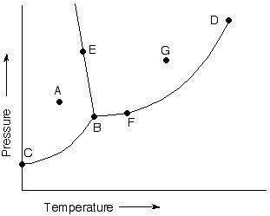
- What phases are present at points A through H?

H•

- Label the triple point, normal boiling point,
normal freezing point, and critical point on
the diagram.

- Which phase is more dense: solid or liquid?

- Use the accompanying phase diagram for carbon to answer the following questions.

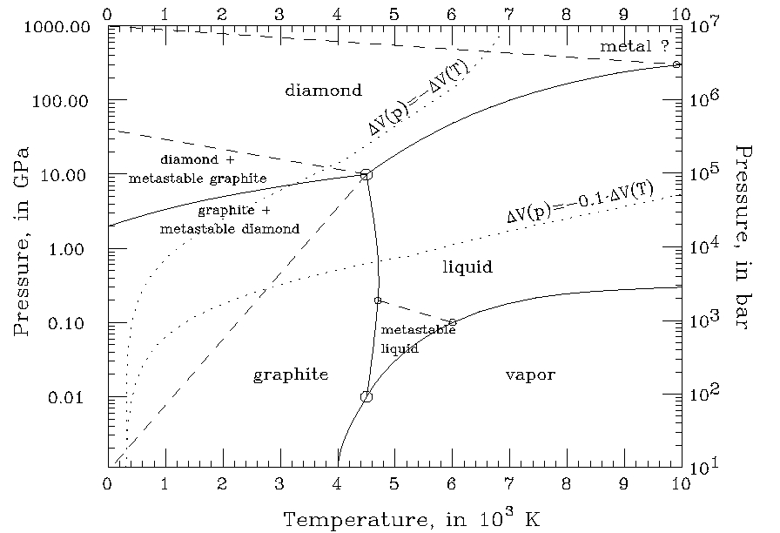

- How many triple points are in the phase diagram?

- What phases can coexist at each triple point?

- What happens if graphite is subjected to very high pressures at room temperature?

- If we assume that the density increases with an increase in pressure, which is more dense: graphite or diamond?

- Consider the following data for xenon:

Triple point: -121°C, 280 torr
Normal melting point: -112°C
Normal boiling point: -107°C

- Which is more dense: Xe _{(s)} or Xe _{(l)}?

- How do the melting point and boiling point of xenon depend on pressure (how does a change in pressure affect these temperatures for xenon)?

Answers to Selected Problems
11. 1.47 x 10⁵ torr
12. a) 51°C b) 221 torr
13. 1.67 x 10³ kJ
21. 52.5°C
22. 4650 g H₂O

